INVENTION DISCLOSURE FORM (IDF) FOR PATENT APPLICATION

This Invention Disclosure Form (IDF) is used to gather information for evaluating your invention in terms of patentability requirements such as novelty, inventive step and industrial applicability.

Please make use of this form to furnish the invention details and make sure that the relevant attachments are provided.

All information provided herein and their enclosures are strictly confidential subject matter.

Mandatory Fields***
01 |  | - TITLE OF THE INVENTION*** (Title of the invention shall disclose the specific features of the invention)
- ANS: |  | SYSTEM AND METHOD FOR TENANT-SCOPED HYBRID GRAPH-VECTOR KNOWLEDGE REPRESENTATION AND QUERY-TIME REASONING USING A DUAL-PURPOSE NODE INDEX THAT STORES GRAPH-DATABASE ELEMENT IDENTIFIERS ALONGSIDE EMBEDDING VECTORS
- 02 |  | - COMMUNICATION DETAILS OF THE APPLICANT(S) AND THE INVENTOR(S)***
APPLICANT(s) DETAILS***
Name of Applicant(s) |  |  |  |  |  | Ashwin Ravi
Type of the Applicant  (mention as “YES” under the relevant type) |  |  |  |  |  | Natural person/s | Start-up |  |  |  |  | Small entity |  | Educational Institution |  |  | Others/Large Entity
Nationality
Country Of Residence
Full Correspondence Address of Applicant/s
(residential address)
Please mention as “YES” and attach the proof of entity for e.g. Udyog Aadhar certificate, MSME certificate and or any related proof of Small Entity, Educational institution/Startup)
Contact Details |  |  |  |  |  | Phone
 |  |  |  |  |  | Mail
If the inventor address is same as applicant’s address.
- If “YES”, please mention & leave blank on below address;
- if “NO”, please fill in the below address details)
INVENTOR(S) DETAILS***
S.  No. | Name of Inventor(s) (First Name, Middle Name, Surname) |  |  | Gender | Nationality |  |  |  | Country Of Residence |  | Full Correspondence Address of Inventor(s) |  |  |  |  | Contact Details
1 |  |  |  |  |  |  |  |  |  |  | [same as applicant] |  |  |  |  | Phone
 |  |  |  |  |  |  |  |  |  |  | Street
 |  |  |  |  |  |  |  |  |  |  | City |  |  |  |  | Mail
 |  |  |  |  |  |  |  |  |  |  | State
 |  |  |  |  |  |  |  |  |  |  | Country
 |  |  |  |  |  |  |  |  |  |  | Pin code
2 |  |  |  |  |  |  |  |  |  |  | House No. |  |  |  |  | Phone
 |  |  |  |  |  |  |  |  |  |  | Street
 |  |  |  |  |  |  |  |  |  |  | City |  |  |  |  | Mail
 |  |  |  |  |  |  |  |  |  |  | State
 |  |  |  |  |  |  |  |  |  |  | Country
 |  |  |  |  |  |  |  |  |  |  | Pin code
Total Number of INVENTOR(s) = 01
(in case of more than 2 inventors, please replicate the above cells for adding inventors)
03 |  | INFORMATION FOR EXECUTION***  (publications, protection of the idea in future)
What is the current stage in development of this invention  (please mention as “YES” under the relevant stage) |  |  | Basic Ideation |  |  |  |  | Proof of Concept |  |  |  |  |  |  | Experimental Data |  |  | Others  (Please specify)
 |  |  |  |  |  |  |  | YES
Type of the Invention  (Please mention as “YES” under the relevant stage) |  |  | System, Mechanical Arrangement, Device |  |  |  |  | Process flow, Software methodology/algorithm |  |  |  |  |  |  | Composition, Formulation |  |  | Experimental Condition In-vitro/In-vivo
 |  |  |  |  |  |  |  | YES
04 |  | DETAILED DISCLOSURE OF THE INVENTION***
- Field of the invention [Broader subject area of the invention] ***
Ans:
The invention relates to computer-implemented information retrieval and knowledge representation, and specifically to systems and methods that ingest heterogeneous documents, build a tenant-isolated knowledge graph in conjunction with one or more vector indices, and answer natural-language queries grounded in that graph and those vectors using a large language model.

More specifically, the invention concerns a hybrid graph-vector knowledge substrate in which a single node-level vector index serves two purposes: (a) deduplicating candidate graph nodes during ingestion, and (b) anchoring natural-language queries to graph nodes during retrieval. Each record in that node index stores both an embedding of the node's textual signature and the graph database's native element identifier for that node, so a single vector lookup yields a precise graph anchor without any further label-based or fuzzy match step.
- What are the Novel/New aspects of the invention? What is the inventive step? [What problems are being solved by the invention] ***
Ans:

The invention is a tenant-scoped hybrid graph-vector knowledge substrate. Its central novelty is that a single node-level vector index stores, alongside each embedding, the graph database's element identifier for the corresponding node. This one-to-one binding lets the same index drive both write-time deduplication of candidate nodes and read-time anchoring of natural-language queries, removing the lossy label-matching step that conventional graph-augmented retrieval systems rely on.

The principal novel aspects are:

1. Four-store substrate populated by a single ingestion pipeline.
One pipeline simultaneously produces and maintains four complementary stores from each ingested document:
(a) a property graph holding typed nodes (documents, chunks, entities, concepts, propositions, procedures, steps, table schemas) and edges drawn from a closed relationship vocabulary;
(b) a chunk-level vector index for semantic passage retrieval;
(c) a procedure-level vector index for retrieving standard- operating-procedure (SOP) intents; and
(d) a node-level vector index — referred to here as the "graph node index" — that holds an embedding and the graph element identifier of every node of selected types in the property graph.
Every record in every store is scoped to a tenant identifier, so tenants are isolated at the storage layer rather than at the application layer.

2. Dual-purpose node index with native graph-identifier binding.
Each record in the graph node index comprises (i) an embedding vector derived from a textual signature of a graph node, and (ii) the graph database's native element identifier for that node. The same index is queried in two paths:
(i) Write path. During ingestion, each candidate entity or concept extracted from a chunk is embedded and used to cosine-search the index. If the top hit's similarity exceeds a node-type-specific threshold and the hit's node type matches the candidate, the candidate is merged into the existing graph node identified by the stored element identifier. Otherwise a new graph node is created in the property graph and immediately indexed in the node index together with its newly assigned element identifier, so it is available to deduplicate against subsequent candidates in the same batch.
(ii) Read path. At query time, the natural-language query is embedded and cosine-searched against the same index. The element identifiers returned by the search are used directly as graph anchors for subgraph expansion. There is no intermediate label-to-graph-node lookup.
Holding the graph element identifier inside the vector record — and using one index for both purposes — is the key novel feature.

3. Closed relationship vocabulary with two-stage enforcement.
The property graph is constrained to a fixed, finite vocabulary of relationship types. The vocabulary is enforced (i) at extraction time, by typing the language-model output schema so the model is constrained to emit only in-vocabulary types, and (ii) at write time, by a graph-store gate that rejects any out- of-vocabulary edge. This double gating prevents the schema drift that systems with open-ended LLM-generated relationships develop over time.

4. First-class procedure representation as a directed acyclic graph.
When a document is identified as a standard operating procedure, the system constructs a directed acyclic graph in the property graph: one Procedure node, one Step node per step, structural edges from the Procedure to each Step, ordering edges between Steps derived from explicit prerequisites or from sequential numbering, and reference edges from each Step to entities mentioned in that Step's description. Procedure intents are independently indexed in the procedure-level vector store, and step descriptions are independently indexed in the node-level index. This enables retrieval at procedure granularity, at step granularity, and via entities referenced by steps.

5. Streaming pipeline with structured progress events.
Ingestion proceeds through a fixed sequence of stages — parse, chunk, extract, resolve, store. After each stage the system emits a structured progress event over a streaming channel, carrying a stage identifier, status, work-counts, and elapsed time. A client application can render the pipeline in real time and surface failures at the stage that caused them.

6. Atomic tenant lifecycle.
Every persisted record carries a tenant identifier. A single atomic operation, exposed as one API call, removes a tenant completely: it drops each per-tenant collection from each vector index and removes every node and edge in the property graph that carries that tenant identifier.

7. Provider abstraction for language and embedding models.
The system exposes a uniform interface for language-model providers and a uniform interface for embedding-model providers. The choice of provider and model is made by configuration, not by source modification. The same ingestion and query paths run unchanged across any combination of supported providers, including locally hosted models.

Problems solved (for each of which the corresponding novel aspect is in parentheses):
- Lossy label-based mapping between vector hits and graph nodes (aspect 2).
- Schema drift from open-vocabulary LLM-emitted relationships (aspect 3).
- Cross-tenant data leakage and difficult tenant cleanup (aspects 1, 6).
- Inability to retrieve and reason over standard operating procedures at procedure granularity, step granularity, or via step-to-entity references (aspect 4).
- Operational opacity of long-running ingestion (aspect 5).
- Vendor lock-in to a particular language or embedding model (aspect 7).
- Maintaining two parallel indices, one for write-path deduplication and one for read-path retrieval (aspect 2).
- Is there any prior art for this invention: [Has the problem been solved/ Is the problem being solved in any other manner by others. Limitations and drawbacks of prior art] ***
Ans:

Closest prior arts known at the time of filing:

1. Microsoft GraphRAG — Edge et al., "From Local to Global: A Graph RAG Approach to Query-Focused Summarization" (arXiv:2404.16130). A graph-augmented retrieval system that builds an entity graph and uses community-detection plus LLM-generated community summaries.
Limitations: single-tenant; uses label-based matching to map vector hits to graph nodes; no first-class procedure DAG; open-ended LLM-emitted relationship types.

2. LightRAG — Guo et al. (arXiv:2410.05779). A dual-level retrieval framework combining low-level (entity-specific) and high-level (topic-level) retrieval over a knowledge graph.
Limitations: no SOP/procedure modelling; no tenant isolation; vectors and graph stored independently with no shared identifier in the vector record.

3. HybridRAG — Sarmah et al. (arXiv:2408.04948). Combines a knowledge graph and a vector store for financial document Q&A using rank fusion at query time.
Limitations: vector and graph are loosely coupled with no write-time deduplication via the vector index; no constrained edge vocabulary; no tenant model.

4. Cognee (cognee.ai). An open-source semantic memory system for AI agents that constructs entity graphs from documents.
Limitations: does not store the graph element identifier inside the vector record (requires a label lookup at query time); no constrained edge vocabulary with storage-side enforcement; no tenant-scoped multi-tenancy as a first-class concept; no procedure DAG with step-level entity references.

5. Graphiti / Zep — Rasmussen et al. (arXiv:2501.13956). A temporal knowledge-graph memory architecture for conversational agents.
Limitations: focused on conversational memory rather than document ingestion at scale; no procedure DAG; vector–graph linkage by label rather than by graph element identifier; no provider abstraction.

6. LlamaIndex KnowledgeGraphRAGRetriever and LangChain GraphCypherQAChain. Open-source orchestration toolkits for building hybrid KG-plus-vector RAG pipelines.
Limitations: these are construction kits, not end-to-end substrates. They provide neither the dual-purpose node index, nor a constrained-vocabulary graph schema enforced at storage time, nor first-class tenant isolation across all stores, nor the procedure DAG primitive.

Consolidated drawbacks of the prior art:
(a) Label-based mapping between vector hits and graph nodes, which is lossy under variant casing, hyphenation, or abbreviation and causes silent retrieval failures.
(b) Open-vocabulary LLM-emitted relationships causing graph schema drift and brittle downstream traversals.
(c) Single-tenant assumption or weak application-layer multi-tenancy.
(d) Absence of first-class SOP modelling with step-level entity references.
(e) Vendor lock-in to specific language or embedding models.
(f) Opaque, unobservable long-running ingestion pipelines.
(g) Separate write-path and read-path indices doubling storage and compute.
- Describe how the invention is more beneficial or feasible over the prior art. [What are the advantages/improvements of the invention as compared to solutions provided by others] ***
Ans:

Advantages and improvements over the prior art:

1. Precision anchoring. By holding the graph element identifier inside each node-index record, a single vector search yields the exact graph anchor — no label re-resolution. This eliminates a class of silent retrieval failures present in systems that map vector hits to graph nodes via label matching.

2. Write-time deduplication using the read index. The same node index drives both ingestion-time deduplication and query-time anchoring. Each node is embedded once and the embedding does double duty, halving the vector-store footprint and removing the maintenance burden of keeping two indices in sync.

3. Maintainable, queryable graph schema. The closed relationship vocabulary, enforced both at extraction time (typed model output) and at storage time (write-side gate), keeps the graph schema consistent over indefinite operation, enabling reliable templated traversals and analytics.

4. Storage-layer tenant isolation. Per-tenant collections in each vector index plus a tenant-identifier property on every graph node and edge make multi-tenancy correct by construction. Tenant deletion is atomic and complete in a single API call.

5. Procedure-aware reasoning. The procedure DAG and the step-to- entity reference edges enable a query class — "which procedures reference entity X?", "what is the next step after Y?", "which entities are touched by procedure P?" — that pure-RAG and pure- vector systems cannot answer.

6. Provider portability. Language and embedding models are selected by configuration. The same paths run unchanged across cloud- hosted and locally hosted providers, reducing vendor lock-in and permitting cheaper local models on non-critical paths.

7. Deployment portability. The same substrate runs against self-hosted graph and vector databases or against managed equivalents, with no source modification.

8. Operational observability. The structured per-stage progress stream lets operators see live counts, latencies, and the exact stage at which a long-running ingestion job failed, instead of treating ingestion as a black box.

9. Extensibility. Clear extension points exist for community detection, temporal/bi-temporal metadata, edge weight decay, distilled task-specific small language models, and additional query primitives without disturbing the substrate.

10. Cost efficiency. The dual-purpose node index, the constrained edge vocabulary (which removes the need for post-hoc edge cleanup), and the swappable provider layer (which permits local models for non-critical paths) together yield a substantial reduction in operating cost relative to a baseline graph- augmented retrieval implementation at equivalent quality.
- Provide a detailed explanation of your invention: [Specifically describe all the element and components of the invention. Also describe how all the elements and components work together to form the invention. For more clarity and understanding, respective examples, diagrams, flowcharts, etc may be provided] ***
Ans:

OVERVIEW

The system is a hybrid graph-vector knowledge substrate. It comprises a client application, a server application, and a four-store data layer (one property graph plus three vector indices), and integrates with one or more language-model providers and one or more embedding-model providers via a provider abstraction.

The four-store data layer holds:

(i) A property graph with eight typed node labels and a closed vocabulary of relationship types. Node labels include Document, Chunk, Entity, Concept, Proposition, Procedure, Step, and TableSchema. Every node and every edge carries a tenant identifier.

(ii) A chunk-level vector index. Each record corresponds to one document chunk and stores the chunk text, an embedding derived from the chunk text, and source/position metadata.

(iii) A procedure-level vector index. Each record corresponds to one procedure and stores its name, intent text, an embedding derived from the intent, and a serialised list of steps.

(iv) A node-level vector index ("graph node index"). Each record corresponds to one graph node — of type Entity, Concept, Procedure, or Step — and stores: (a) a stable node key; (b) the graph database's native element identifier for the corresponding node; (c) the node type; (d) the textual signature from which the embedding is derived; and (e) the embedding vector.

The graph node index is the central spine of the system. It is the sole source of identity binding between the vector world and the graph world.

INGESTION PIPELINE

A document arrives at the server with an associated tenant identifier and proceeds through five stages:

Stage 1 — Parse. The document is parsed into a structured representation that respects layout, sections, tables, and other structure-bearing features. The parser supports common business-document formats. The output is a structured document object.

Stage 2 — Chunk. The structured document is partitioned into chunks of bounded length while respecting natural boundaries (sections, tables, paragraphs). Each chunk carries a chunk identifier, a source location, and a document-type label.

Stage 3 — Extract. For each chunk, an extraction module invokes a language model under a typed output schema. The schema constrains the model to emit:
- entities (a label, a type, and a description),
- concepts (a name, a definition, and aliases),
- relationships (source, a relationship-type drawn from a closed finite vocabulary, target),
- propositions (subject, predicate, object, and the originating chunk identifier), and
- for documents identified as standard operating procedures, procedures (a name, an intent, and an ordered list of steps, each step carrying a step number, description, prerequisites, and a responsible party).
Constraining the relationship-type field to the closed vocabulary at extraction time prevents the model from emitting out-of-vocabulary types in the first place.

Stage 4 — Resolve. A resolver module deduplicates candidate entities and concepts against the existing graph. For each candidate it constructs a textual signature; for an Entity candidate, the signature combines the label and description; for a Concept candidate, the signature combines the name, definition, and aliases. The resolver embeds the signature and submits it as a similarity search to the graph node index, scoped to the tenant. The decision rule is:

(a) If the top hit's similarity exceeds a node-type threshold (typically tighter for entities than for concepts) AND the hit's node type matches the candidate AND the hit carries a graph element identifier, the candidate is merged into the existing graph node identified by that element identifier. The candidate's properties are folded into the existing node; no new node is created.

(b) Otherwise a new node is created in the property graph, yielding a fresh element identifier, and the new node is immediately indexed into the graph node index together with its element identifier. Subsequent candidates in the same chunk or document can therefore deduplicate against this newly created node.

Stage 5 — Store. The remaining graph structure is persisted: a Document node; one Chunk node per chunk, with a structural edge from the Document to each Chunk; mention/definition edges from each Chunk to those entities and concepts that were extracted from that chunk; and one edge per extracted relationship using the closed vocabulary, where the storage layer rejects any out-of-vocabulary type as a final safety net. For SOP documents the procedure DAG is constructed (see below). The chunk index is populated; the procedure index is populated; and any newly created Procedure and Step nodes are indexed in the graph node index. After each stage a structured progress event is emitted to the client.

PROCEDURE DAG

When the extractor identifies a document as a standard operating procedure, the storage layer constructs a directed acyclic graph in the property graph, comprising:

- one Procedure node carrying the procedure's name, intent, and a serialised step list,
- one Step node per step, carrying the step number, description, and responsible party,
- structural edges from the Procedure node to each Step node,
- ordering edges between Step nodes, derived from explicit prerequisite lists where available and otherwise from sequential numbering, and
- reference edges from each Step node to those entities mentioned in that step's description.

The Procedure's intent is independently indexed in the procedure-level vector store. Each Step's description is independently indexed in the graph node index. As a result, a query can retrieve a procedure by intent, navigate the DAG to a specific step, and follow reference edges to the entities that step touches.

QUERY PIPELINE

A query arrives at the server with an associated tenant identifier:

Step 1. The query is embedded.

Step 2. The query embedding is submitted to the graph node index, scoped to the tenant. The result is a list of hits, each carrying a graph element identifier, the corresponding node type, the textual signature, and a similarity score.

Step 3. Hits with similarity below a configured threshold are discarded. The element identifiers of the surviving hits become the anchor list. No label lookup is required.

Step 4. The graph database is asked to expand a reasoning subgraph rooted at the anchor list, with a configured maximum hop distance and scoped to the tenant identifier. The expansion returns a node list and an edge list.

Step 5. The query embedding is submitted to the chunk-level index, scoped to the tenant, to retrieve evidence passages.

Step 6. The query embedding is submitted to the procedure-level index, scoped to the tenant, with a relevance threshold (so a procedure is only included when it is genuinely relevant to the query).

Step 7. The reasoning subgraph, the evidence passages, and any relevant procedures are assembled into a structured context. Both a textual portion (for the language-model prompt) and a structured portion (for the response payload, including provenance) are produced.

Step 8. The structured context and the query are passed to the language model. The answer is streamed back to the client together with the structured reasoning subgraph and the provenance record.

PROVIDER ABSTRACTION

The system exposes:
- a language-model provider interface accepting a prompt and returning a (streaming) completion, and
- an embedding-model provider interface accepting a text or batch of texts and returning embedding vectors.
Concrete providers are registered at start-up; selection is by configuration. Both interfaces are crossed at well-defined seams in the ingestion pipeline (extraction; embedding) and the query pipeline (anchoring; chunk and procedure search; final completion), so substituting a provider is a configuration change and not a source change.

TENANT MODEL

A tenant is the unit of isolation. Each tenant has:
- a subgraph of the property graph defined by the set of nodes and edges carrying that tenant identifier, and
- one collection in each of the three vector indices, namespaced by the tenant identifier.
A single atomic deletion operation, exposed as one API endpoint, drops each per-tenant collection and deletes every graph node and edge that carries that tenant identifier.

EXAMPLE — TELECOMMUNICATIONS OPERATIONS KNOWLEDGE BASE

A telecom operations team uploads a heterogeneous corpus: network inventory data, standard operating procedures (e.g., circuit decommissioning), governing compliance regulations, and architecture documents. The pipeline parses, chunks, and extracts across the corpus; the resolver deduplicates, so a circuit identifier referred to as both "CID 44821" and "CID-44821" collapses to a single graph node; relationships are stored under the closed vocabulary (e.g., a circuit is provisioned-from a specific network element, a procedure is governed-by a specific regulation); the procedure DAG is built for each SOP, with each step's reference edges to mentioned entities.

A field technician then asks: "What is the procedure to decommission CID-44821, and what regulation governs it?" The query pipeline embeds the question, anchors it via the graph node index to the circuit entity, the decommission procedure, and the governing-regulation concept; expands the reasoning subgraph including the procedure DAG and the governs edge; pulls supporting evidence chunks; assembles the context; and produces a step-by-step answer with provenance pointing to the document, the procedure, the steps used, and the regulation concept.

ALTERNATIVE EMBODIMENTS

The components are deliberately substitutable. The property graph may be implemented in any property-graph database supporting a declarative traversal language. The vector indices may be implemented in any vector database supporting cosine approximate-nearest-neighbour search. The document parser may be any format-aware parser supporting layout-aware extraction. The language model may be any text completion model; the embedding model may be any text embedding model; both may be cloud-hosted or locally hosted. The closed relationship vocabulary may comprise more or fewer types and may be tuned to a domain. The maximum hop distance in subgraph expansion may be one, two, three, or more. The similarity thresholds for resolution and for anchor filtering may be tuned per deployment without departing from the invention. The system may be deployed in a self-contained configuration, in which the graph and vector databases run alongside the application, or in a managed-service configuration, in which one or both are managed externally.
- Provide Drawings, if any. [Please note: Drawings need to be provided in 2D/3D line drawing format, with and without labelling. We request you to provide the descriptive of numerical labelling below the drawings.] ***
Ans:

The figures below illustrate the invention. They are provided as separate pages in the accompanying drawio file (trident_patent_figures.drawio); each figure carries reference signs that match the in-text citations and will be re-rendered in patent-office-compliant 2D line-drawing format prior to formal filing.

FIG. 1 — System architecture overview.
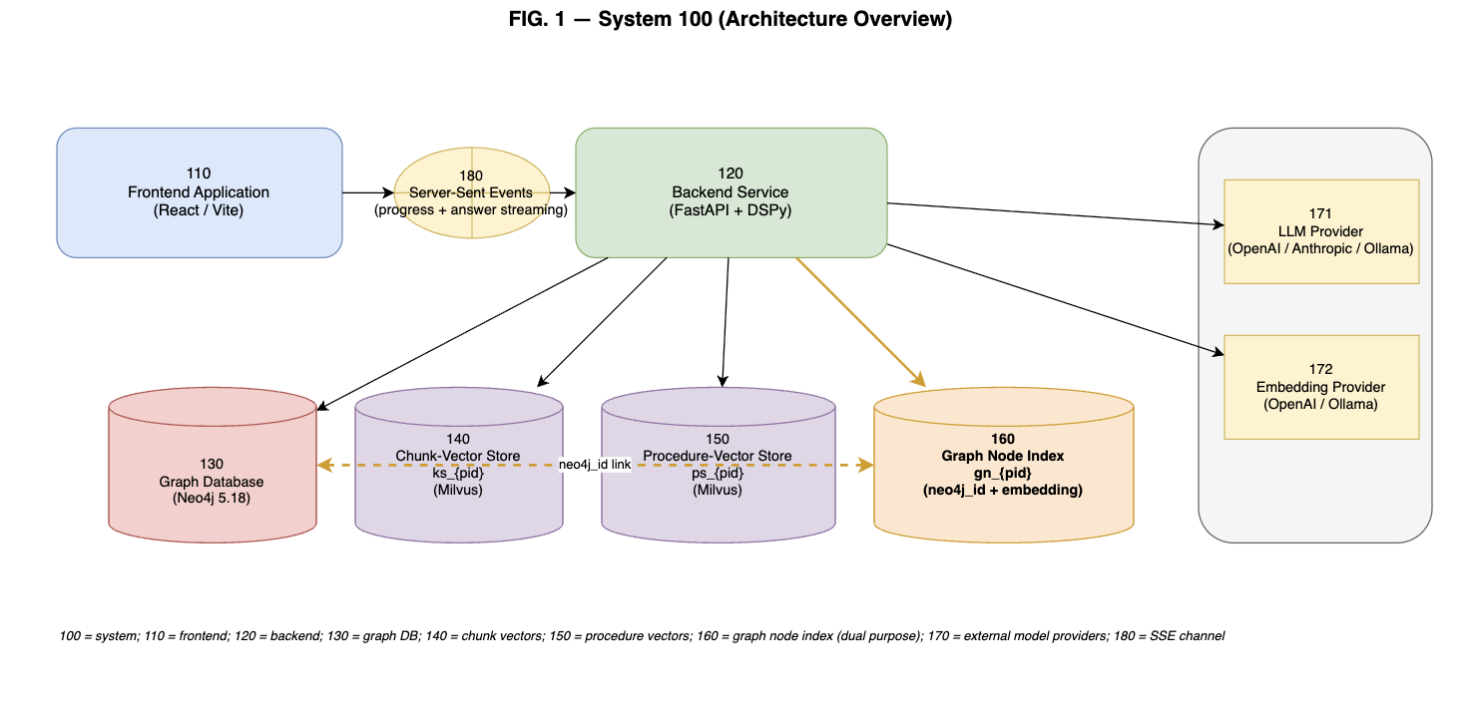
Client application 110, server application 120, property graph 130, chunk-level vector index 140, procedure-level vector index 150, graph node index 160, external model-provider services 170 (language-model provider 171, embedding-model provider 172), and the streaming progress channel 180.

FIG. 2 — Four-store data layer.
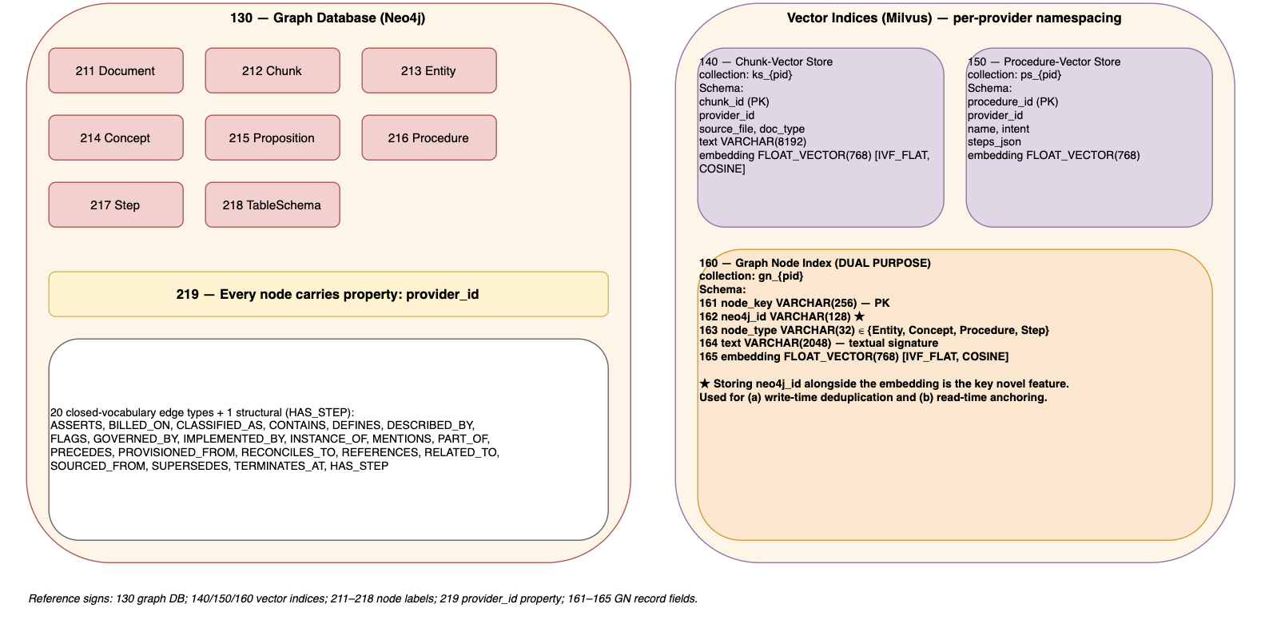
Eight node labels of the property graph (Document 211, Chunk 212, Entity 213, Concept 214, Proposition 215, Procedure 216, Step 217, TableSchema 218); the tenant-identifier property 219 carried by every node and every edge; the three per-tenant vector collections; and the graph node index record schema (node key 161, graph element identifier 162, node type 163, textual signature 164, embedding 165), with the graph element identifier highlighted as the novel field.

FIG. 3 — Five-stage ingestion pipeline.
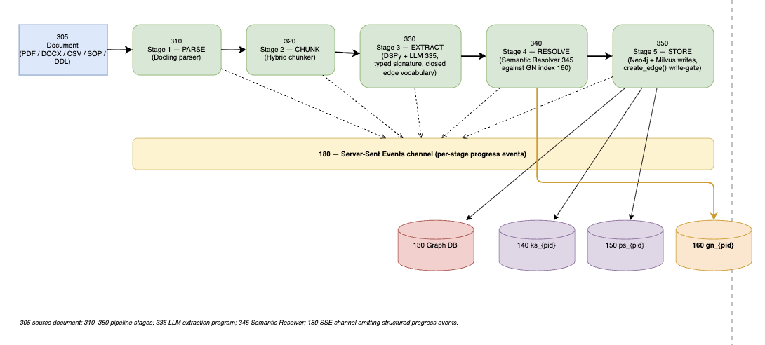
Parse 310 → Chunk 320 → Extract 330 (with the language model 335) → Resolve 340 (with the resolver 345) → Store 350. After each stage a structured progress event is emitted on the streaming channel 180. Stage 5 writes to the property graph, the chunk index, the procedure index, and the graph node index.

FIG. 4 — Procedure DAG.
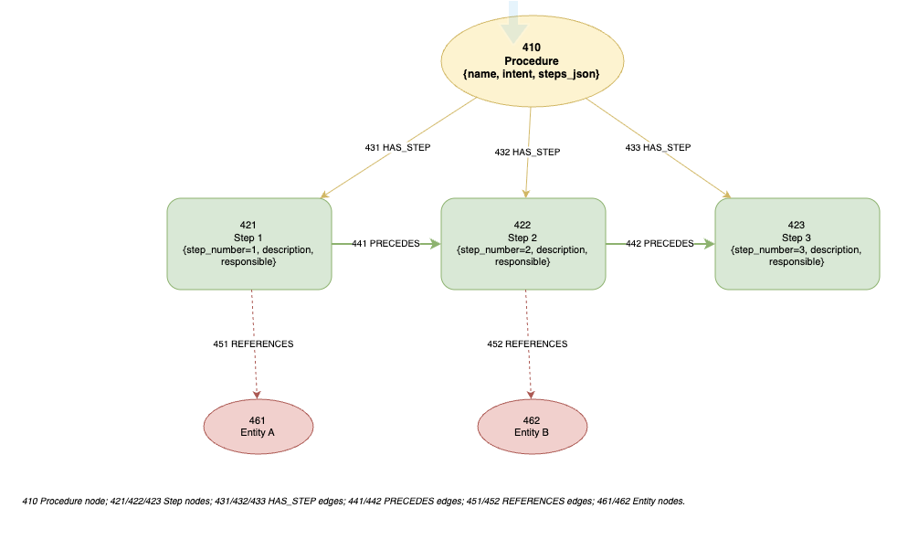
Procedure node 410, Step nodes 421/422/423, structural edges 431/432/433 from the Procedure to each Step, ordering edges 441/442 between Steps, and reference edges 451/452 from Steps to Entity nodes 461/462.

FIG. 5 — Dual use of the graph node index.
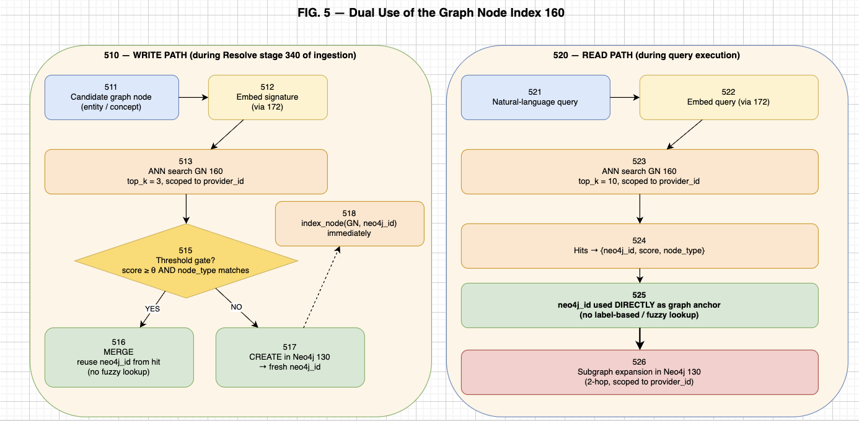
Write path 510 — candidate node 511 → embed 512 → index search 513 → threshold gate 515 → either merge 516 with the existing node identified by the stored graph element identifier, or create 517 in the property graph and immediately index 518 with the new graph element identifier.
Read path 520 — query 521 → embed 522 → index search 523 → hits 524 → graph element identifiers used directly 525 as graph anchors → subgraph expansion 526.

FIG. 6 — Query pipeline.
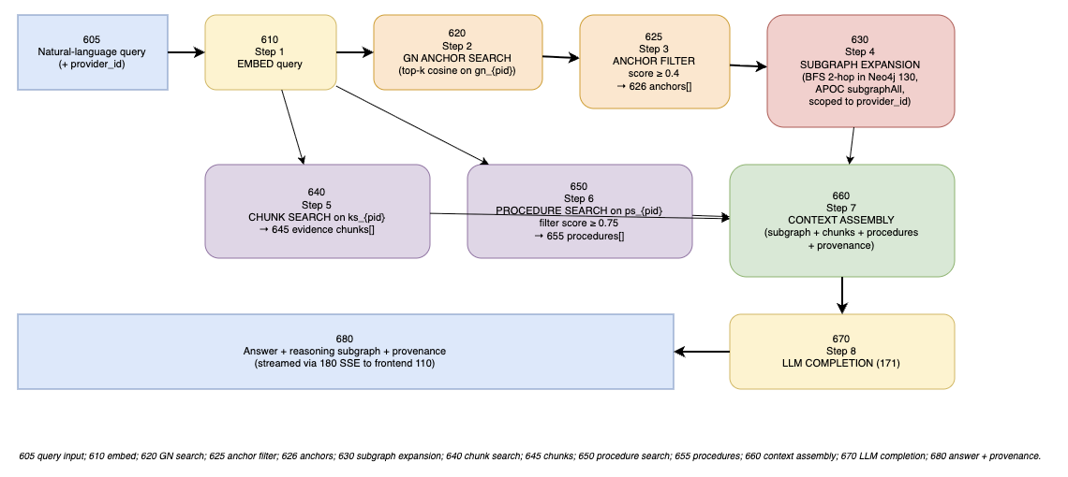
Step 610 (embed) → 620 (graph node index search) → 625 (anchor filter) → 626 (anchors) → 630 (subgraph expansion) → 640 (chunk search) → 645 (chunks) → 650 (procedure search) → 655 (procedures) → 660 (context assembly) → 670 (language-model completion) → 680 (answer plus reasoning subgraph plus provenance, streamed via 180 to client 110).

FIG. 7 — Tenant model.
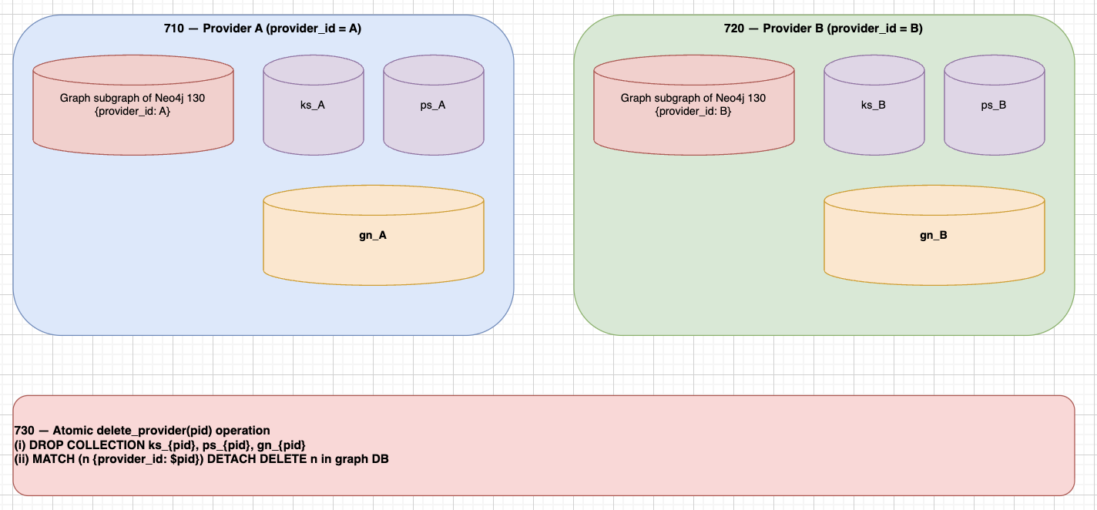
Tenant A 710 and Tenant B 720, each with an isolated property- graph subgraph and three per-tenant vector collections. The atomic delete operation 730 drops all per-tenant collections and removes all graph nodes and edges carrying that tenant identifier in one API call.

Does this invention relate to any other prior arts: {If “YES”, please share the details (Issued/Grant patents, Pending patent application, Previous submitted IDF with improvements) or else mention as “NO”} *** |  |  |  |  |  |  |  |  |  | NO. To the inventor's knowledge, no prior patent has been filed by the applicant or any assignee on this specific invention. The non-patent literature prior arts identified above are public research and open-source projects; none of them, individually or in any reasonable combination, discloses the invention's combination of (a) the four-store tenant-scoped substrate, (b) the storage of the graph database's element identifier inside each record of the node-level vector index, (c) the dual use of that index for both write-time deduplication and read-time anchoring, (d) the closed relationship vocabulary with two-stage enforcement, and (e) the procedure DAG with step-to-entity reference edges. No previous IDF has been submitted by the inventor on this subject matter.
Is any traditional knowledge being relied on? (please mention “YES” & provide details or else mention as “NO”) *** |  |  |  |  |  |  |  |  |  | NO. The invention does not rely on any traditional knowledge.
Is there any biological material being used? (please mention “YES” & provide details or else mention as “NO”) *** |  |  |  |  |  |  |  |  |  | NO. The invention does not use any biological material.
Has the invention ever been shown or used in public? (please mention “YES” & provide details or else mention as “NO”) *** |  |  |  |  |  |  |  |  |  | NO. The invention has not been disclosed in any public forum, conference, or publication. The implementation is held in a private repository and has not been published, demonstrated, or offered for sale. No academic paper, blog post, or social-media post has been made. Any third-party review of the implementation to date has been under confidentiality. Novelty has been preserved as of the filing date.
Are you intended to pursue International Patent? (please mention “YES” & provide details or else mention as “NO”) *** |  |  |  |  |  |  |  |  |  | YES. The applicant intends to pursue international patent protection.
Please specify if any additional inputs from inventor(s)/applicant(s) as suggestion (Worldwide Search, Territorial Search and or Others):

.

We thank you for entrusting our service(s) and submitting the Invention Disclosure Form.

